



How to Set up SonarQube



Table of Contents
Table of Contents 2
Revision History 3
1. Purpose 4
2. Pre-requisites 4
2.1. JDK Version 4
2.2. SonarQube Server 4
2.3. SonarQube Scanner 4
2.4. Accenture Quality Profile 4
3. Steps 5
3.1. Extract sonarqube-8.9.1.44547.zip and sonar-scanner-cli-4.6.2.2472 .zip to your local folder 5
3.2. Add sonar-scanner to your system environment variables by: 5
3.3. Create a file sonar-project.properties to your project’s root directory 6
3.4. Start SonarQube server by launching ‘StartSonar.bat’ under: sonar_server_root_folder\sonarqube-8.9.1. 1.44547\bin\machine_OS_version example: C:\SONARv4\sonarqube-8.9.1.44547\bin\windows-x86-64 7
3.5. Confirm if SonarQube is up by opening it from your browser. 8
3.6. Login as admin using the following default credentials: username: admin password: admin 8
3.7. Import Accenture Quality profile to SonarQube by doing the following: 8
3.8. Go to your project’s root directory, then open cmd/terminal and execute this command: “sonar-scanner -X” 8
3.9. Wait for the message “EXECUTION SUCCESS” from the command prompt/terminal then go to SonarQube's site (http://localhost:9000/projects), your project must appear in SonarQube's dashboard. 9
3.10. After every update, you must scan your project again then refresh the browser. 9

Revision History
Version | Date | Summary | Updated By
1.1 | 3/21/2022 | Update Documentation | Jhayzon Lonn Santos

Purpose
This document will guide you on how to scan your Java Project and find out if it adheres to the latest Accenture JAVA coding standards.

Note:
Projects created using lower version of Java 11 such as Java 8 will still work with the latest version of SonarQube.

Pre-requisites

JDK Version
Java 11 version should be installed on your local machine.

Note:
For windows machine, if multiple JDK Version is installed on your computer, Java 11 location should be declared first in your 'Path' environment variable.

SonarQube Server
Download SonarQube server from this location: https://binaries.sonarsource.com/Distribution/sonarqube/sonarqube-8.9.1.44547.zip

SonarQube Scanner
Download SonarQube scanner from this location: https://binaries.sonarsource.com/Distribution/sonar-scanner-cli/sonar-scanner-cli-4.6.2.2472.zip

Accenture Quality Profile
Download Accenture Quality profile version 4 from this location: accenture-java-qualityprofile-v.4.0.xml

Steps

Extract sonarqube-8.9.1.44547.zip and sonar-scanner-cli-4.6.2.2472 .zip to your local folder
Note: Create a folder to your C:/ then extract it to the folder’s directory.

Add sonar-scanner to your system environment variables by:
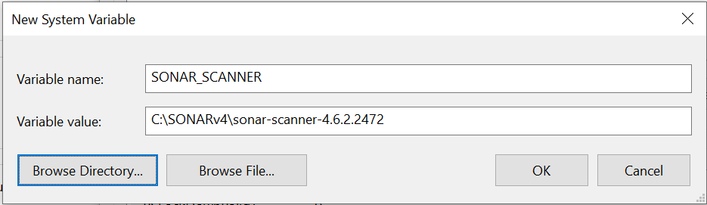
- Creating a new variable
Notes:
*Variable value is the directory of your sonar scanner.
*The path should not include the bin folder.
q
- Add %SONAR_SCANNER%\bin to the Path Variable
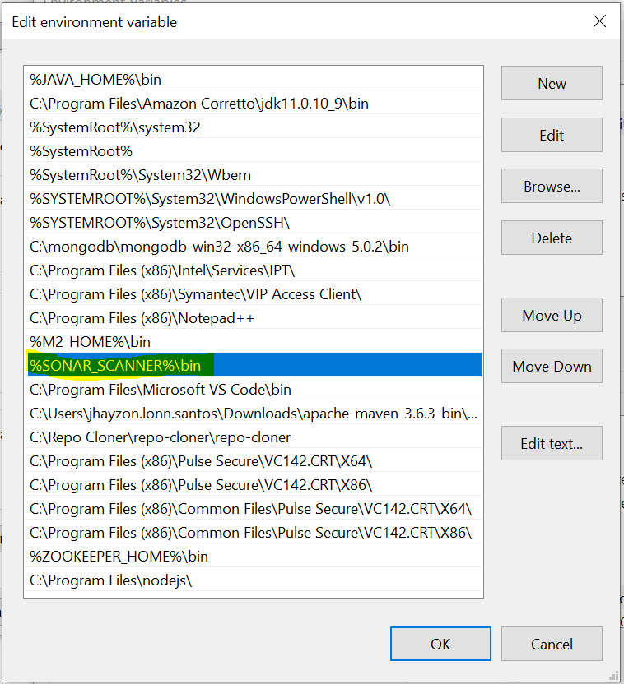

Create a file sonar-project.properties to your project’s root directory
The file should contain these configurations:

# required metadata
sonar.projectKey=<Project Key> - can be the same as the project name
sonar.projectName=<Project Name> - can be the same as the project name
sonar.projectVersion=1.0

# optional description
sonar.projectDescription=Scan project.

# path to source directories (required)
sonar.sources=src/main/java
sonar.java.source = 1.11

# path to test source directories (optional)
# sonar.tests=testDir1,testDir2
# path to project binaries (optional), for example directory of Java bytecode
# sonar.binaries=binDir
sonar.java.binaries=target

# optional comma-separated list of paths to libraries. Only path to JAR file is supported.
#sonar.libraries=lib/*.jar
# The value of the property must be the key of the language.
sonar.language=java

# Additional parameters

# sonar.my.property=value
# setting sonar credentials through generated token
sonar.login=<generated token from sonarqube***>

# setting the port of sonarqube
# sonar.host.url=<port where sonarqube is running>
# ex:
sonar.host.url=http://localhost:9000

#prevent scm error
sonar.scm.disabled=true

***this version of sonar requires credential before we can scan our project, but we can provide token, generated by sonarqube instead of username and password.
To generate token, read this documentation: https://docs.sonarqube.org/latest/user-guide/user-token/

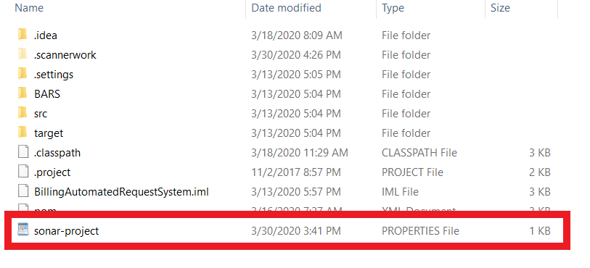
Note: Project should be a maven project and should be run once so that it has a target folder.

*Make sure to double check your file to prevent errors like setting the file name into sonar-project.properties and then the file type will be properties. It will be read as sonar-project.properties.properties

Start SonarQube server by launching ‘StartSonar.bat’ under:
sonar_server_root_folder\sonarqube-8.9.1. 1.44547\bin\machine_OS_version
example: C:\SONARv4\sonarqube-8.9.1.44547\bin\windows-x86-64
Note: Wait for the message in the console: ‘SonarQube is up’, It should be up and do not close it because that is the server.

Confirm if SonarQube is up by opening it from your browser.
http://localhost:9000

Login as admin using the following default credentials: username: admin
password: admin

Import Accenture Quality profile to SonarQube by doing the following:
- Go to http://localhost:9000/profiles
- On the top right most of the page, click on 'Restore' beside 'Create' button.
- Click on 'Choose File' and locate 'accenture-java-qualityprofile-v4.0.xml' in your local folder, which is stated in the pre-requisite section, finally click on 'Restore'.
- It should display: 175 rule(s) restored in profile "accenture-java-qualityprofile-v4.0"
- Set the accenture-java-qualityprofile-v4.0 as default by clicking the settings button then set as default.

Go to your project’s root directory, then open cmd/terminal and execute this command:
“sonar-scanner -X”

Wait for the message “EXECUTION SUCCESS” from the command prompt/terminal then go to SonarQube's site (http://localhost:9000/projects), your project must appear in SonarQube's dashboard.

After every update, you must scan your project again then refresh the browser.

